MINISTRY OF SCIENCE AND HIGHER EDUCATION OF THE RUSSIAN FEDERATION

VORONEZH STATE UNIVERSITY" FGBOUEU VO

Department of Mathematics

COURSEWORK

on the discipline "Software Development Tools"

"Dragon Mountain" game.

The author of the work is the "Three Kingdoms" team Course 3 Group 1;2

PICS direction 09.02.03

Evaluation___________________

Accepted by Zenin K.V.

Voronezh 2023

Content:

Introduction 3

What are arcades? 4

Arcades on PC 4

Language 5

Direction 6

Time spent on video games 7

Origin of the name and idea of the game 8

The full version of the picture 11

Scheme 12

Minimum requirements for the game 13

Scope 13

Conclusion 14

Sources 15

# Introduction

2022 was a year of lull in the game industry: blockbusters[1] can be counted on your fingers. It was left to look for salvation only in indie games[2] . But[3] gamers should not despair, the new year will bring many high-profile game releases.

One of these games will be not known to anyone before the game Dragon Mountain. Dragon Mountain - a new arcade game, the essence of which is that you must choose one of the proposed balls with a carp koi further he either turns into a dragon or remains a carp.

If a dragon falls out, it's a win and you'll be rewarded with praise and an increase in your win count, but if a carp falls out, it's a loss and you'll be belittled in every possible way. The developers say that they don't want players to take insults to heart, as they are only needed to motivate players, build their character and increase their faith in victory.

The action of the game takes place at the dragon gate on Lunmen Shan Mountain.

# What are arcades?

Learning more about the existing genres of computer games, many people wonder what an arcade is. The term is confusing, but what is most confusing is that it unites a lot of games of different themes. Although they can be very different from each other, but all arcades have a few common features by which they can be easily recognized. These include:

- A simplified but intensive process;

- simplified graphics;

- The lack of a clearly traceable plot;

- Infinity (the game can have a huge number of levels);

- The opportunity to score points for performing various actions;

- the small amount of time it takes for them to pass;

- Having multiple lives to be able to complete the same level multiple times.

The word arcade itself comes from the English language, in which it is a synonym for the word passage, which means a covered passage or corridor - a gallery, in which arcade machines were placed in rows. Arcades themselves in their original form were popular until the early 2000s: in the 1980s-1990s. As computer games and consoles became more widespread, arcade machines became less popular.

## Arcades on PC

However, the genre had not yet exhausted itself, so the famous arcades were imported, and a number of new ones were created specifically for the computer. Of course, with a number of adaptations. The main feature of the genre - simplified gameplay and graphics - remained unchanged.

Today, arcades remain a common genre of computer games. Thanks to the fact that there are many varieties of them, everyone can find one that suits their interests. They are played on computers, consoles, and even on cell phones.

# Language

When development of the game first started, there was a question about what language the game should be in.

Since no consensus was reached by the developers, multiple market studies were conducted that showed these results.

The report details the current trends in the industry. The research surveyed 16,900 respondents from four leading regions:

* North America (U.S. exclusively);
* Latin America (Brazil and Mexico);
* EMEA countries;
* Asia-Pacific countries.

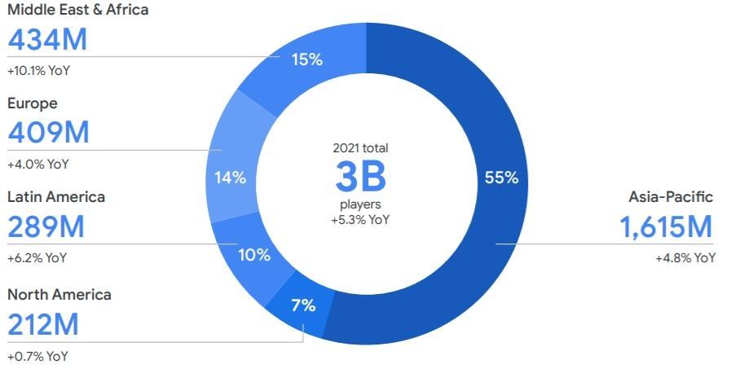

Fig.1

This study suggests that the Dragon Mountain game has the potential to spread among 55% of the total number of players with Russian and Chinese localization.

# Direction

In order to calculate the possible profit of the game (at the same time its budget) and also to know more precisely what audience the game will be directed to in the future, research was also conducted.

In 2020, 173 million new people became addicted to games. 65-70% of them said in a survey that they will not give up their hobby even after the pandemic is over.

Experienced gamers spend the most on games or in-game purchases - 78% of this audience category. However, among new or returning gamers there are also quite a few of them - 73%. In addition, the researchers found that experienced gamers began to spend more time in titles[4] in the period from February 2020 to May 2021.

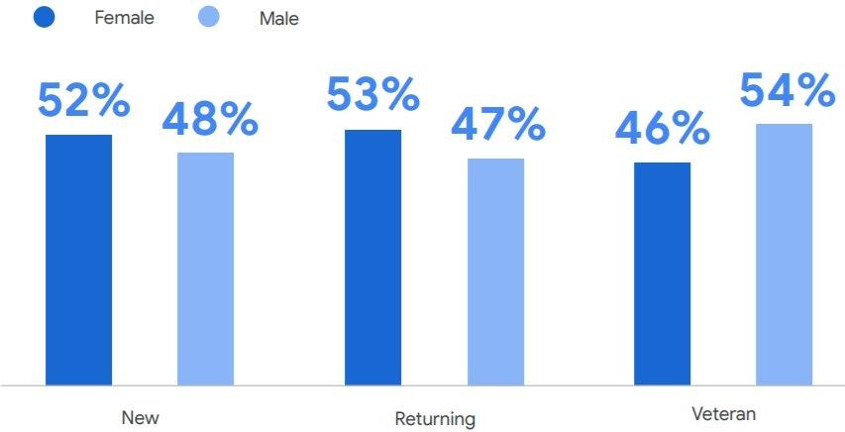It is noteworthy that the majority of newcomers and returning players are girls (52% and 52% respectively). And among experienced gamers, men prevail - 54% vs. 46% of women.

Fig.2

This research has provided a better indication of the direction of the game's design and the difficulty in using it.

# Time spent playing video games

Next, a study was conducted to determine what length of time players count on when logging into the game.

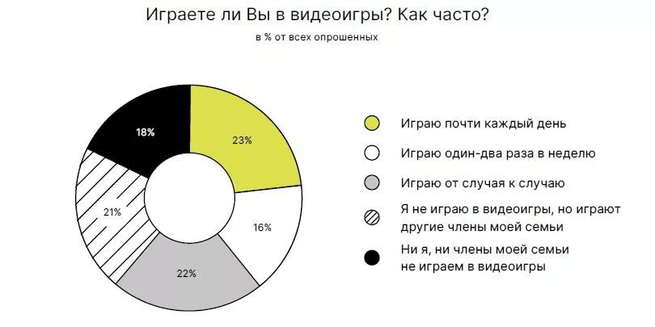38% of Russian gamers devote time to video games no more than once or twice a week. Almost a quarter (23%) play almost every day. Compared to 2018 data, this share has slightly decreased (from 26%).

Fig.3

On average, Russian gamers who devote time to video games occasionally spend 3-5 hours a week playing them. Those who play almost daily spend 3-4 hours a day on video games.

**Origin of the name and idea of the game .**

Why exactly Dragon Mountain and why are there carp in the game besides dragons? In fact, this is a rather simple question, the answer to which can be found in Chinese mythology.

On September 19, the State Museum of Oriental Art in Moscow presented an extremely curious exposition. It is an exhibition of one exhibit, namely a painting of the XVIII century by the Chinese artist Wu Qi. The painting is called "The Carp Turns into a Dragon".

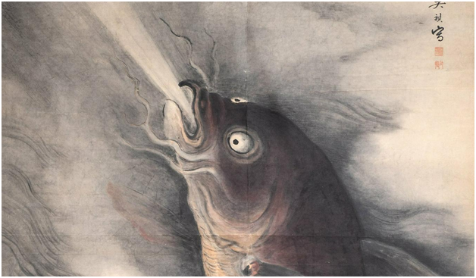

Fig.4

The exposition has a very interesting background. The painting belonged to a prominent sinologist and diplomat, academician Sergei Leonidovich Tikhvinsky, and was recently added to the museum's collection

**Heavenly fire scorches the tail**

The carp in Chinese tradition is one of the basic symbols of popular culture.

Since ancient times, the Chinese have believed that the carp is the chief or prince of all fish. The carp was believed to have a divine essence. He is the only one of all fish capable of becoming a being of a higher order, namely a dragon. The ancient Chinese said that the carp from nose to tail has 36 scales, each of which has a small black spot, and on the forehead of the carp can be seen sign "wang", that is, prince or king.

The ancient text "He Tu" tells the story of how the founder of the Chinese nation, the legendary Huang-di, was walking along the bank of the Luo River and discovered a huge carp three zhang (almost ten meters) long. The body of this primitive carp was dark and had no scales. Suddenly, the Yellow Ancestor saw that the red heavenly pattern on the forehead of the carp was turning into a hieroglyph. This legend is reminiscent of the story of the discovery of writing by the Chinese, when a turtle emerged from the waters of the same river Luo, on the shell of which the characters that later became the basis of Chinese writing became visible.

In general, the carp turning into a dragon is a rather old story in Chinese culture. However, it became widely popular only in the Qing era (1644-1912) in the pictures of the folk loubq nyan-hua. These pictures were produced in large numbers at that time, and people were eager to buy them. Since the carp was a symbol of extraordinary vitality, its images were hung at home and given to friends as a wish of determination in overcoming obstacles, health and, of course, success in education and career. In old China, study and career were closely linked, because only a student who passed the exams could become an official.

The respect for the carp was so great that even Confucius named his only son Kun Li, that is, the Carp of the Kun family.

How could a carp become a dragon? It is believed that in order to do so, it had to jump the Dragon Gate. The earliest mention of this process is found in the ancient text "Er I". Chinese scholars of antiquity believed that the Dragon Gate was a specific geographical location, namely Mount Lunmen-shan, located east of the Huang He. According to legend, the ancient ruler Great Yu cut a passage about one li (576 meters) wide through this mountain. This allowed the Huang He to flow freely and the world was saved from a flood. The passage of the river bed in this place is limited by steep banks - this is the Dragon Gate. It is said that every year in spring, golden carp from all rivers and seas come here to go upstream through the gate and become dragons themselves.

It is believed that only 72 carp can become dragons each year. When a carp crosses the gate, it falls into a cloud of rain and mist, rises up in the cloud, heavenly fire scorches its tail and the carp turns into a dragon.

Funnily enough, modern Chinese scholars are getting into a dispute with their ancient colleagues. They believe that the authentic Dragon Gate is not connected with Mount Lunmen-shan. In the course of the Huang He River, there is a place called Yuimenkou (Great Yu's Gate). It is located on the border between the town of Hejin in Shanxi Province and the county center of Hancheng in Shaanxi Province. It is here, modern scholars say, that the real Dragon Gate is located.

# The full version of the picture

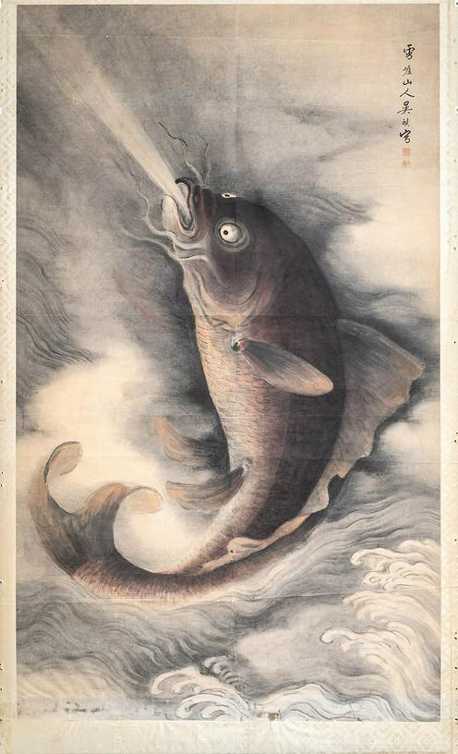

Fig.5

# Functional scheme of the game operation

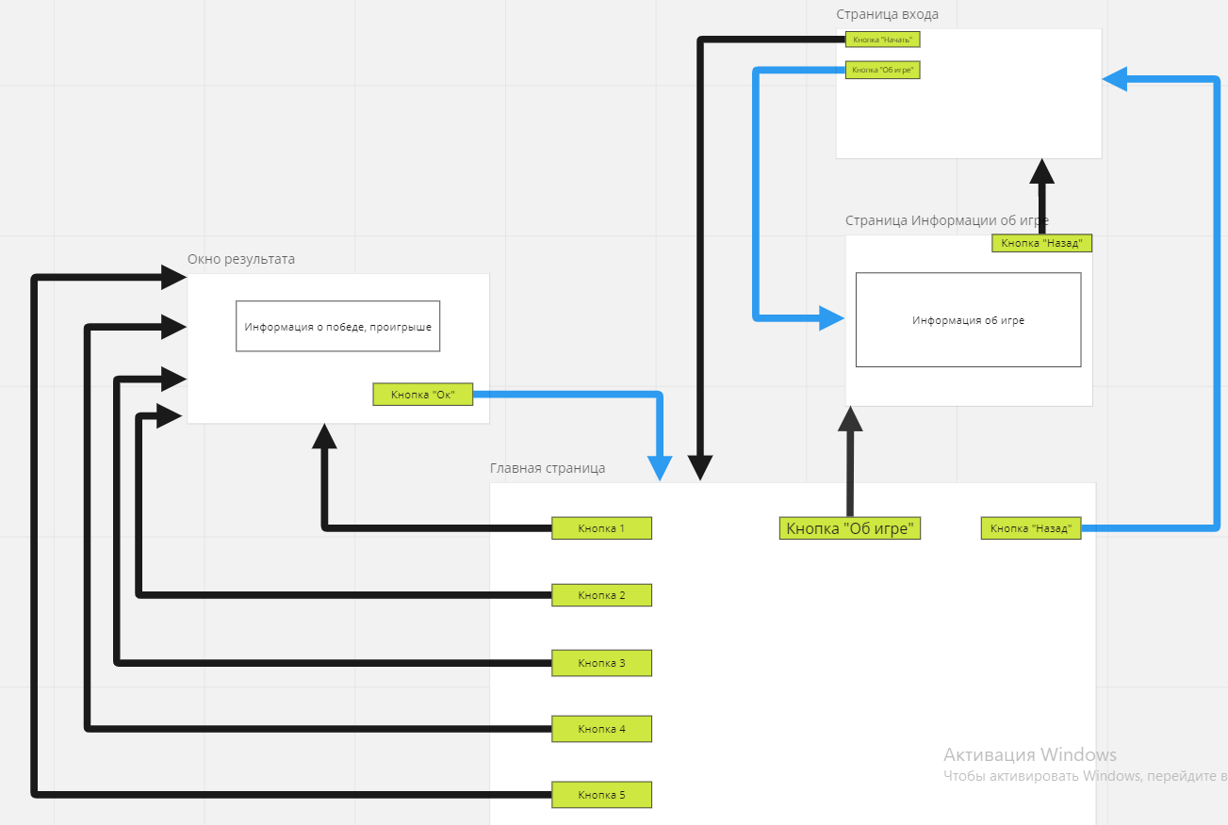Let's consider the scheme of the game's operation:

Fig.6

**System requirements for the game are :**

Here are the minimum requirements for the game:

For PCs:

Operating System: Microsoft Windows XP (32-bit)

Processor: Pentium III, clocked at 1 GHz

Video card: Geforce 3 with 64 MB of video memory

RAM: 4 GB

Disk space: 300 MB

For phones:

Operating System: Android: 4.1 and above

Processor: Unisoc T612 1.82 GHz

RAM: 2 GB

Built-in memory: 16 GB

# 

# Scope of application

This game can be used exclusively in the entertainment industry[5] .

# Conclusion

In this term paper, a literature review was conducted, the historical background of the game was revealed. Current trends in the number of players and their attributes in the industry were examined.

This paper has examined the arcade genre from both a historical perspective and a practical one.

**Dragon Mountain will be released on 10.05.2023 in alpha version. Keep an eye out and don't miss the opportunity to play such an exciting and addictive game!**

# Sources

1. Dzen.ru - <https://dzen.ru/a/Y9eFMkK8pnQDCrhp>

2. Fergana media - <https://fergana.media/articles/110876/>

3. studfile.net - [https://studfile.net/preview/7437487](https://studfile.net/preview/7437487/page:2/#:~:text=%D0%98%D0%BD%D0%B4%D1%83%D1%81%D1%82%D1%80%D0%B8%D1%8F%20%D1%80%D0%B0%D0%B7%D0%B2%D0%BB%D0%B5%D1%87%D0%B5%D0%BD%D0%B8%D0%B9%20%E2%80%93%20%D1%81%D0%B8%D1%81%D1%82%D0%B5%D0%BC%D0%B0%20%D0%BF%D1%80%D0%B5%D0%B4%D0%BF%D1%80%D0%B8%D1%8F%D1%82%D0%B8%D0%B9,%D0%BF%D1%80%D0%BE%D1%86%D0%B5%D1%81%D1%81%D0%B0%20%D1%80%D0%B0%D0%B7%D0%B2%D0%BB%D0%B5%D1%87%D0%B5%D0%BD%D0%B8%D1%8F%20%D1%83%D1%81%D0%BB%D1%83%D0%B3%D0%B8%20%D0%B8%20%D1%82%D0%BE%D0%B2%D0%B0%D1%80%D1%8B)

4. Habr.com - <https://habr.com/ru/companies/mvideo/news/645417/>

5. Polygon.by - <https://polygon.by/advice-on-preparation-of-a-concept-document-for-game-project/>

6. Skillbox.ru - <https://skillbox.ru/media/gamedev/analitiki-k-2023-godu-oborot-globalnogo-geymdevrynka-prevysit-200-mlrd-dollarov/>

7. Otvet.mail.ru - <https://otvet.mail.ru/question/209504823>

8. Nafi.ru - <https://nafi.ru/projects/it-i-telekom/geyming-v-rossii-2022-sotsialnye-i-ekonomicheskie-effekty/>

9. Games.withgoogle.com - <https://games.withgoogle.com/reports/beyondreport/>

10. Information provided by the development team.

1. A very popular and commercially successful product of the (in this case) gaming industry.
2. A game created by a small team with a small budget.
3. A person who plays video games.
4. It is an instance of a game in its "global view". In fact, every game on the game market is a Title.
5. A field of activity aimed at satisfying people's needs for entertainment of various kinds.